University of Louisville

CECS 550, Spring 2018

BRIDGES

User Manual

Team members:

Nikhil Paonikar

Brandon Sparrow

Manorath Dhakal

Pinhao Guo

Isaiah Thomas

# **TABLE OF CONTENTS**

1. **Introduction to the game** ------------------------------------- 4
   1. **Game Requirements and Installation** -------------------- 4
   2. **The Rules of Your Game** -------------------------------- 4
   3. **Game Requirements and Installation**--------------------- 4
2. **Using the Game** ---------------------------------------------- 5
   1. **Terminology** ------------------------------------------- 5
   2. **User Interface ----**-------------------------------------- 5
3. **How To -**---------------------------------------------------- 12
   1. **How to Start a New Game ------**------------------------- 12
   2. **How to Play a Game** ------------------------------------ 12
   3. **Winning** ----------------------------------------------- 12
   4. **Illegal Moves** ------------------------------------------- 12
   5. **Restarting a Game** -------------------------------------- 13
   6. **Quitting the Game -**------------------------------------- 13
   7. **Help** --------------------------------------------------- 13

# **TABLE OF IMAGES**

|  |  |  |
| --- | --- | --- |
| **Sr. no.** | **Image** | **Page** |
| 1 | Screenshot of Main menu | 5 |
| 2 | Screenshot of volume control menu | 6 |
| 3 | Screenshot of Help menu | 7 |
| 4 | Screenshot of level-selection menu | 8 |
| 5 | Screenshot of level-intro | 8 |
| 6 | Screenshot of level (in-game) | 9 |
| 7 | Screenshot of vocabulary tutorial | 9 |
| 8 | Screenshot of conversation practice | 10 |
| 9 | Screenshot of incorrect response in conversation | 10 |
| 10 | Screenshot of correct response in conversation | 11 |

1. **Introduction to the game**
   1. **Game intro**

The main goal of this game is to make the language learning process more fun. Users of this game will learn the basics of Japanese language. With the vocabularies, sentences, and conversation examples in audio and text in the game, users will learn to greet people. Users will be able to address people and give them the directions to the places.

* 1. **The Rules of Your Game**

To play the game, user needs click on the option buttons. As user gets to the actual game scenes, there will be few characters moving around or standing around the scene. User needs to use WASD keys to move around the scene.

* 1. **Game Requirements and Installation**

There are only few requirements of the game. First requirement is that user should have the desktop computers and be connected to the internet in order to play the game. User should be able to understand English language as our game has English as the base language.

1. **Using the Game**
   1. **Terminology**

|  |  |
| --- | --- |
| **Term** | **Meaning** |
| NPC | Non-playable character |
| Level | Current game progression |

* 1. **User Interface**
     1. **Main menu**

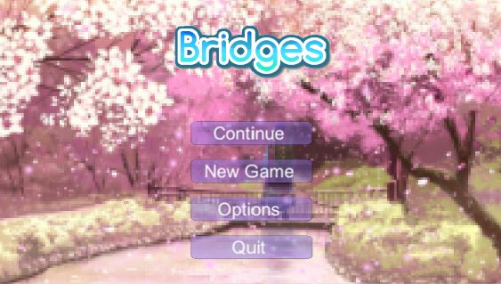

*Image 1: Screenshot of Main menu*

In the main menu, the player can choose one of the four options depicted in the screenshot.

* + 1. **Volume control menu**

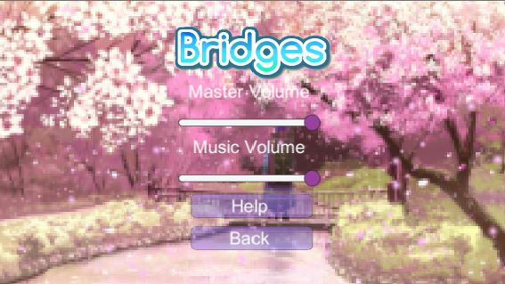

*Image 2: Screenshot of volume control menu*

The music volume and master volume can be changed by clicking the purple buttons and using the mouse cursor to adjust it.

* + 1. **Help menu**

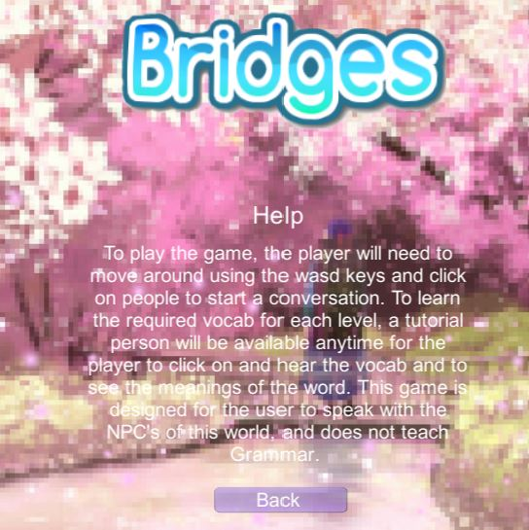

*Image 3: Screenshot of Help menu*

The user can use this sub-menu to get basic instructions on how to play this game.

**2.2.4. Level-selection**

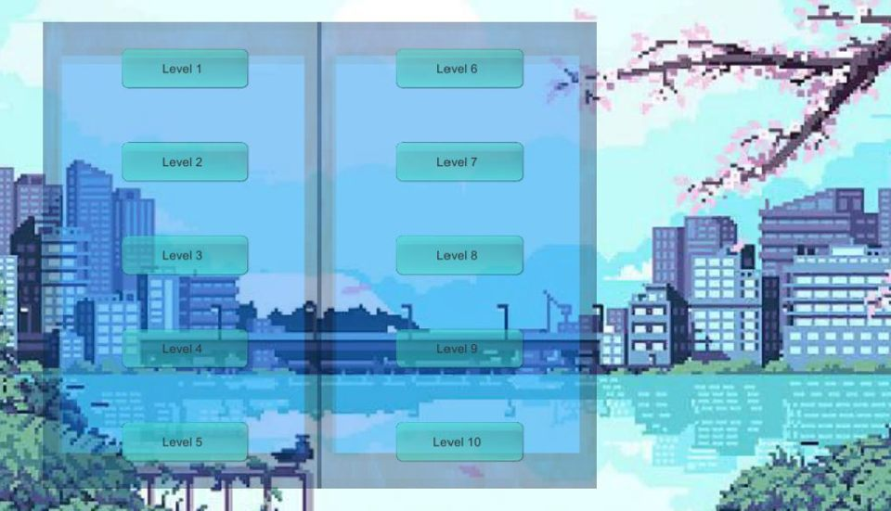

*Image 4: Screenshot of level-selection menu*

This depicts the menu screen from which the user can select a level that he is allowed to.

**2.2.5. Level intro**

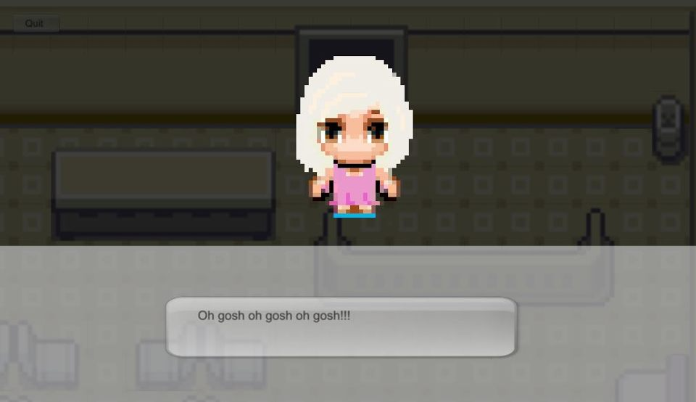

*Image 5: Screenshot of level-intro*

This depicts the start of the level where an NPC appears and commences the level.

**2.2.6. Level example**

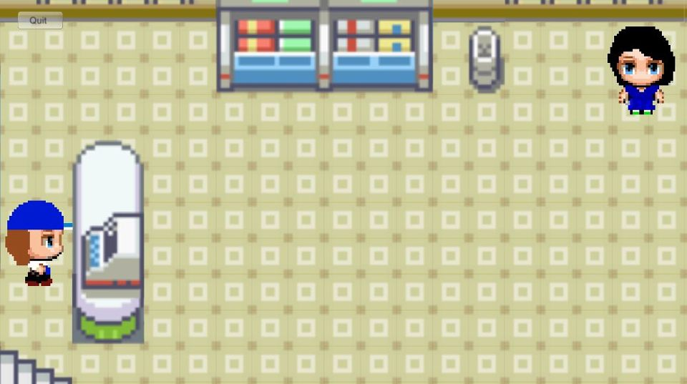

*Image 6: Screenshot of level (in-game)*

This in-game screenshot shows an example of the level map with two NPCs.

**2.2.7. Vocabulary tutorial**

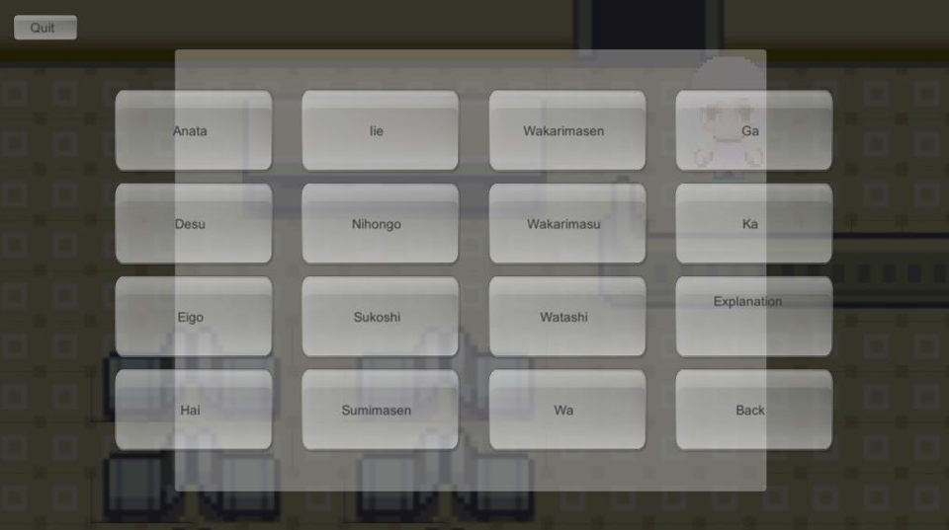

*Image 7: Screenshot of vocabulary tutorial*

This in-game screenshot shows the vocabulary-tutorial buttons.

**2.2.8. Conversation practice**

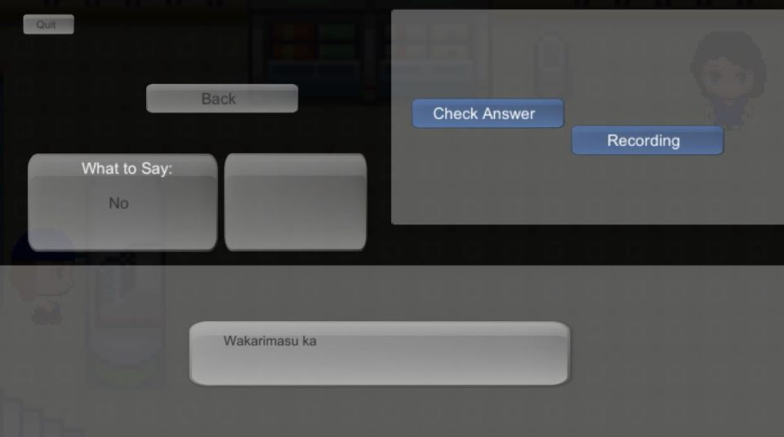

*Image 8: Screenshot of conversation practice*

This in-game screenshot shows the conversation practice screen where the player can engage in conversation to progress to the next level.

**2.2.9. Incorrect response**

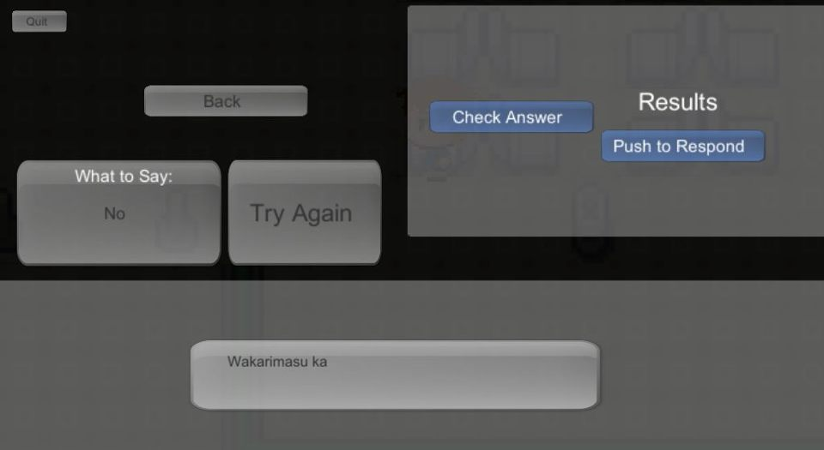

*Image 9: Screenshot of incorrect response in conversation*

An incorrect response will not contribute to level-progression and prompts the user to try again.

**2.2.10. Correct response**

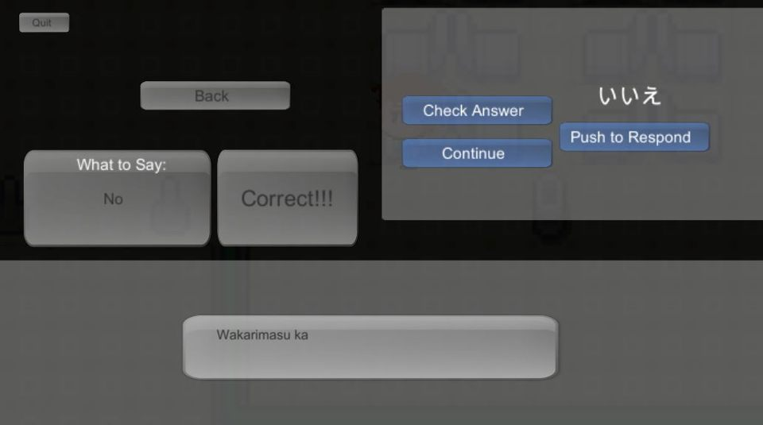

*Image 10: Screenshot of correct response in conversation*

A correct response awards the user points and allows the user to go to the next part of the conversation.

1. **How To**
   1. **How to Start a New Game**

When user opens the game, there will be the list of options including “New Game”, and “Continue”. When user clicks on “New Game” option, menu screen with list of the different levels will display. From there, user will be able to choose the level they want to play. When user clicks on “Continue” option, one of the level that user previously quitted while playing will open.

* 1. **How to Play a Game**

When user gets to any of the levels, there will be a setting where the story of the game is taking place, few characters will be in each scene. One of the characters will be teaching vocabulary. When user clicks on this character, conversation will be played, and user will be given some speaking quizzes. When user clicks on the other characters, list of vocabularies and sentences will be displayed. From there user will be able to play the audio for particular words or sentences they clicked on. Another NPC will allow user to practise their Japanese conversation skills. The NPC will ask questions and user must click on the “push to record” button to vocally answer in Japanese. An incorrect response allows the player to retry; a correct response leads to game progression.

* 1. **Winning**

While user is listening/reading to the conversation examples, he/she will be given few questions to answer after few conversations. Each question is worth about 20 points, and total of 100 points is needed to win the game. After reaching the winning points, user will be able to play next level.

* 1. **Illegal Moves**

There are no any illegal moves in the game. User have options to choose between the characters to play learn something.

* 1. **Restarting a Game**

There is a back button on the game to go back to the main menu. There will have option to play the game from the beginning.

* 1. **Quitting the Game**

Back button is displayed on each scene. When user clicks on the back button, it will take user to the main menu. Main menu contains the option to quit the game.

* 1. **Help**

In the main screen of the game, there is a help button.